Basic Rules:

The Fate Roll:
When a character takes an action that could fail, the player may be asked by the GM or a rule to make a ‘Fate Roll’. The player rolls 1d20. If the number on the face is higher than the DC shown in table 1, the action succeeds.

Table 1 : Difficulty Class (DC)
Difficulty | DC
Piece of Cake | 5
Not Hard | 10
Average | 15
Troublesome | 20
Pretty Tough | 25
Super-Heroic | 30

The Chance Roll:
The GM, or a rule may also give the player a percentage chance to succeed at a particular task. In this case, the player rolls 2d10, one representing the tens position, and one representing the ones position. If the number shown on the die is less than the success chance, the action succeeds.

Hit Points (HP):
The character starts with maximum of 30 HP. When current HP reaches Zero, the character falls unconscious, and can take no action. At -10, the character Flat-Lines. A Flat-Lined character, must be revived within 1 minute (12 rounds). 1 hour of rest restores 1 current HP until the maximum has been reached.

Energy Points (EP):
Each character starts with 5 EP which can be spent on actions that may be psychologically or physically taxing. A character with 0 energy points is exhausted, and has disadvantage on success rolls. Some props may add a new Energy Point sub-category. This sub-category may be something like Magic Points (MP) that can only be spent on techniques tagged with ‘Magic’. Once the sub-category has been exhausted, the player may choose to push themselves by using EP in it’s place. 1 hour of rest restores 5 EP, until the maximum has been reached.

Action Points (AP):
The character has 5 points to spend on actions each turn. Moving 5 feet costs 1 AP. An unarmed attack costs 2 AP. Pulling something out of your bag or putting something in; sheathing/unsheathing a weapon; and getting up from a prone position - all cost 4 Action Points.

Loadouts:
The props currently being held by the character. Some objects require 2 hands to operate, and will be tagged with ‘2-Hand’. Switching loadouts costs 4 AP, and includes switching props to and/or from one or both hands, with props in the pack.

Combat:
The player chooses a target, and makes a Chance Roll. By default, if the character is within 5 feet of a single target, the player may roll an icosahedron. If the number on the face is higher than the target’s Defense, the attack is a success. Unarmed attacks do 1 damage.

Character Cards:
Th

Experience Points (XP):
The GM awards the character XP for successfully completing a task. The player saves these points until they can afford a particular character Card. The GM will decide when XP can be spent. The Card is a new rule, or a bonus to a statistic or roll. An easy battle earns each character 1 XP. An average battle earns them 2 UPs, and a difficult one can earn 3 or 4 UPs. These can also be awarded for good role-playing, clever tactics, finding treasure, solving puzzles, etc..

Power Level:
Th

Base Character Sheet:

( Name )
HP:  EP:  AP:  Attack:  Defense: | 30 / 30  5 / 5  5  Fist +0 ~ 5ft./One target/1 dam.  10+0

** Every character starts with this as their base. Change the name and add upgrades from the GM’s approved upgrade list to make the character unique. It’s up to the GM how many UPs you will start with, but 50 or 60 are good numbers for a new character. All characters are assumed to have a bag, and a regular outfit by default.
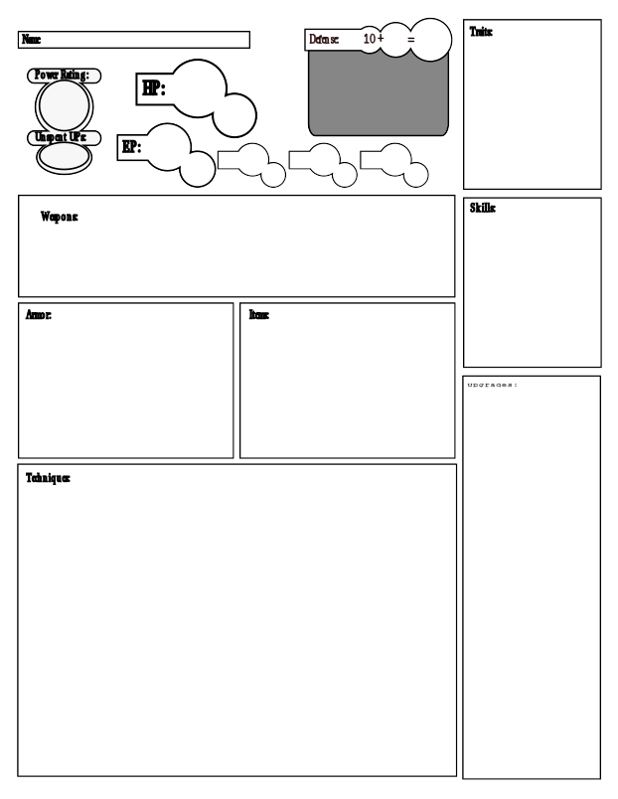

Character Catalog (CC):
A Character Catalog is a list of ‘Cards’ which represent the character’s growth and progress. There are multiple types of Cards, each with their own rules.

Props:
A Character’s powers and skills come primarily from their gear, and ability to use it. The following Card types can branch off into an entire field of training, starting with one of these as a ‘root’. Props that are the base of a power tree will be tagged with ‘root’, and branch Cards will be tagged with ‘branch’. Props are broken into the following 8 sub-types:

Tools:
Tools are stored in the Character’s pack unless otherwise noted, and can be retrieved as long as the character has a free hand at the cost of 4 AP. A tool may be required to perform a task

Weapons:
Weapons will each have their own rules, and are assumed to come with a sheath, or scabbard.

Armor:
Will be tagged with one or more locations on the body. Only one item per location is recommended. If the character is wearing armor tagged with ‘Outfit’, no other armor should be equipped, except ones tagged with ‘finger’ and ‘neck’. Each character has a ‘finger’ slot for each finger that character actually has, not including thumbs.

Companions:
A p

Consumables:
A p

Books:
A p

Vehicles:
A p

Phenotypes :
Optional rule. Resembles a ‘race’ in other systems. Determines the character’s physical description, and may confer some special abilities or drawbacks. Phenotypes tagged ‘genetic’ can only be purchased at character creation, and only if the GM approves. Other Phenotypes may be given by the GM without spending UPs. In this case the UP cost for the Phenotype Card is still added to the character’s Power Rating.

Secondary Cards:

Techniques:
A Technique is an Upgrade that can be used when the player chooses. Techniques may incur an Energy Point cost, and/or an Action Point cost to the character.

Upgrades:
an upgrade permanently Modifies a technique, item, or even the character. If it is a character mod, changes are made to the character’s stats. Otherwise the mod applies to the specified parent upgrade in the current power tree.

Additional Card Information:

When the player makes a success roll, they may choose a skill and a trait received from a CC, and add them to the result (at the GM’s discretion). The player must justify the use of each skill or trait.

Skills:
A skill represents training, and the ability to effectively perform a particular task.
(Examples: Spot, Throw, Research)

Traits:
A trait represents a physical quality the character has at their disposal.
(Examples: Smart, Strong, Charming)

Filters:
Each upgrade will have a TL score, and an FL score between 0 and 5. TL stands for Technology Level, and FL stands for Fantasy Level. This will help GMs filter out unnecessary upgrades.

Tags:
Tags provide a bit more detail regarding the nature of the upgrade and how it should be handled.

Table 2 : Technology Level (TL)
Technology Level | (TL)
No-Tech. Cave-man. Primitive. | 0
The wheel. Metal tools. | 1
Covered wagons. Flint-lock pistols. | 2
Automatic weapons. Motorized vehicles. | 3
Computers. Primitive Robots. | 4
Space Travel. Androids. Power-Armor. | 5

Table 3 : Fantasy Level (FL)
Fantasy Level | (FL)
Not even a talking pig. | 0
Rarely people may know of minor magics. | 1
A select group can summon moderate power. | 2
Magic and monsters are abundant in some areas. | 3
Your neighbor has a pet dragon. | 4
Alice in wonderland | 5

“Bob’s Basic” ( CC )
Prop List:
Weapons - Battle-Axe, Baseball Bat, Flashlight, Knife, Laser Sword, Mace, Magic Wand, Machete, Pistol, Revolver, Semi-Automatic Rifle, Sword, Sledgehammer, Short Bow, Shotgun, Spear, Wrench.
Armor - Hand Wraps, Helmet, Bullet-Proof Vest, Mecca Suit, Space-Suit, Covert Communicator, Knee Pads, Combat Boots, Item Sash, Suit of Armor, Wizardly Robes, Leather Jacket, Primitive Furs, Ring of the Bear, Ring of the Lion, Ring of the Hare, Pack Organizer, Heads-Up display, Jet-Boots, Championship Belt.
Companions - Horse, Dog, Wolf, Falcon, Crow, Gremlin, Giant Spider, Owl, Monkey, Cat, Tiger.
Tools - Grappling Gun, Rope, Cigarette Lighter, Holy Symbol, Medicine Bag, Flute, Spyglass, Pocket Computer, Cast-Iron Pan, Re-Breather, Juggling Balls, Magnifying Glass, Multi-tool, Grooming Kit, Lock Pick, Pocket Knife.
Consumables - Health Potion, Energy Drink, Grenade, Oil Pot, Caltrops, Zip-Ties, Canteen, Timed Bomb, Taser Gun, Flares, Torch.
Books - Holy Book, Dictionary, Calisthenics Handbook, Grimoire Vulpecula, Fashion Magazine, Gun Magazine, Occult Encyclopedia, Driving Handbook, Book of the Eye, Nature Magazine.
Vehicles - Car, Motorcycle, Bicycle, Speed-Boat, Hover-bike, Scooter.
Phenotypes - Dwarf, Elf, Cambion, Reptilian, Yeti, Wolf-Man, Zombie, Vampire, Gnome, Cyborg, Hamster.

Baseball Bat (14 UP):
(Weapon, TL:1, FL:0)
Hands: 1
Melee Attack:
2AP / +4 / 5ft.
1d8 / single target / bashing
++ Character Trait: Tough +2
[Melee, 2-Hand, Slashing]

|
Stunner (8 UP):
requires: Battle-Axe
(Technique, TL:3, FL:0)
Cost: 3 AP & 1 EP
Range: 5ft.

A : +4 / 1d10 !Stun! / bashing
++ Character Trait: Tough +1
[Upgrade, Weapon]

Battle-Axe (14 UP):
(Weapon, TL:1, FL:0)
Hands: 2
Melee Attack:
3AP / +1 / 5ft.
2d10 / single target / slashing
++ Character Trait: Strong +2
[Melee, 2-Hand, Slashing]

|
Cleave (8 UP):
requires: Battle-Axe
(Technique, TL:3, FL:0)
Cost: 3 AP & 1 EP
Range: 5ft.

A : +2 / 2d10+strong / slashing
B : +1 / 2d8+strong / slashing
++ Character Trait: Strong +1
[Upgrade, Weapon]

Bashlight (14 UP):
(Weapon, TL:4, FL:0)
Hands: 1
Melee Attack:
2AP / +4 / 5ft.
1d6 / single target / bashing
A high-powered titanium flashlight designed to double as a club. If the bashlight is in your loadout, you light up a 40ft. Cone in the direction you’re facing.
++ Character Skill: Spot +1
[Melee, 1-Hand, Bashing]

Semi-Automatic Rifle (14 UP):
(Weapon, TL:3, FL:0)
Hands: 2
Melee Attack:
2AP / +2 / 5ft.
1d4 / single target / bludgeoning
Ranged Attack:
4AP / +(aim) / 60ft.
2d8 / single target / ballistic
Reload:
1 clip / 10 shots / 5 AP
++ Character Skill: Aim +2
[Ranged, Firearm, 2-Hand, Ballistic]

|
Clip (8 UP):
requires: Semi-Automatic Rifle
(Prop Upgrade, TL:3, FL:0, Stack: 4)
++ Semi-Automatic Rifle: + 1 clip
[Upgrade, Weapon]
|
Scope (8 UP):
requires: Semi-Automatic Rifle
(Prop/Character Upgrade, TL:3, FL:0)
++ Semi-Automatic Rifle: + 30 ft. Range
++ Semi-Automatic Rifle: !! If the target is further than 20 ft. away, and on a successful ranged attack, do +3 additional ballistic damage. !!
++ Character Skill: Aim +1
[Upgrade, Weapon, Character]

Kinfe (Weapon, TL:1, FL:0)
(14 UPs):
Cost: 2 AP
Hands: 1
Attack: +2 5ft.
Damage: 1d4 slashing/piercing
[concealable, blade, 1-Hand, piercing]
- Back-stab (Technique, TL:1, FL:0)
(11 UPs, requires: Dagger):
Character skill: Sneak +2.
If you have not been seen by the enemy, are in melee range, and the enemy is facing away from you, add +5 to the attack roll, and multiply the damage by 2.
- Dagger Marksman (Mod, TL:1, FL:0)
(9 UPs, requires: Dagger):
Character skill: Throw +2.
Melee attack +1
Ranged attack +Throw (10+(5*throw))ft.
Add tag “Thrown”
The dagger can now be thrown using the throw skill as an attack bonus. A thrown dagger can fly up to (10+(5*Throw) feet with a maximum of 40ft. Once thrown, the dagger can then no longer be used until recovered. Spending 2 AP recovers.
  - Juggler (Mod, TL:1, FL:0)
(10 UPs, requires: Dagger Marksman):
Character skills : Juggle +3 & Throw +1.
You now have 6 daggers. When one is thrown, spending 1 AP produces another. When all 6 are used recovering them costs 3 AP.
  - Target Practice (Mod, TL:1, FL:0)
(8 Ups, requires: Dagger Marksman):
Character skill: Throw +2.
Character EP +2
Attack +1
Regular training keeps you ready for action.
- Quick-slash (Technique, TL:1, FL:0)
(6 UPs, requires: Dagger):
Once per round you may spend 1 EP to make an extra dagger attack as a free action.
- Needle Storm (Technique, TL:1, FL:0)
(10 UPs, requires: Dagger):
Spend 3 EP to make all dagger attacks this round do +2 damage. Does not stack.

Example Power Sets:

Upgrades can be handled in a similar fashion to ‘classes’ in other RPG systems. The actual shape and form of your ability trees and upgrades are limited only by your imagination, and can be used to emulate your favorite game system, or universe.

Fire Effects (Mod, TL:0, FL:2)
(18 UPs):
This character can now produce a flame out of thin air. Add 5 to the EP score total of this character. Starting a campfire, or burning a scroll can be done by touch, as a free action, at the cost of 1 EP.
- Fireball (Technique, TL:0, FL:2)
(15 UPs, requires: Fire Effects):
[Cost: 1EP & 2AP, Range: 25 ft., Target: Single Enemy, Damage: 1d6 fire, To Hit: +10 VS Def. requires line-of-sight, a free hand, and the ability to speak.]
This character can now aim their palm towards an enemy, and speak the command to shoot a flaming orb at them.
( Tags: fire, ranged, magic )
- Flame On (Technique, TL:0, FL:3)
(16 UPs, requires: Fire Effects):
[Cost: 5EP & 1AP, Target: Self]
At the cost of 5 EP, and 1 AP, this character is engulfed in blue fire for the remainder of combat, or until doused with water. While on fire, successful melee attacks done against this character do 2 points of fire damage to the attacker.
- Twin Dragons (Technique, TL:0, FL:3)
(18 UPs, requires: Fire Effects):
At the cost of 3 EP and 4 AP, this character unleashes two flaming dragons that will find their targets from up to 60 ft. away, dealing 1d12 damage to each. Automatically succeeds.
- Fiery Disposition (Mod, TL:0, FL:2)
(17 UPs, requires: Fire Effects):
Reduce the EP cost of all ‘Fire Effects’ Techniques by 2. If this would drop the EP cost below 1, set it to 1. This character now has the skill : Intimidate +3

